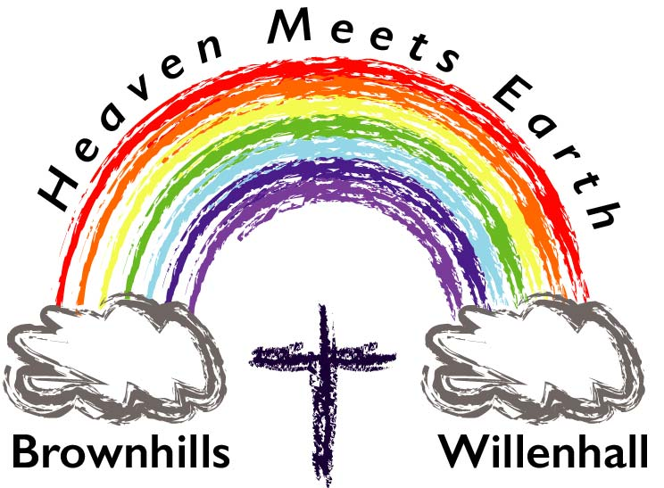
minister@stjohnsbloxwich.co.uk
Revd Jem Hawkins
Brownhills & Willenhall
Methodist Circuit

1st July 2020

Dear Friends,
Over the last 3 months, our buildings have been closed, but the church has been alive and living the gospel through people
- praying
- supporting food banks
- shopping for others
- providing food parcels for vulnerable families
- finding new ways of worship (online, social media, at home and mailings)
- online services, Bible studies and prayer meetings
- supporting each other through phone calls, emails, prayers and love.

The church is alive in our homes and communities for we are the church.

Soon it will be possible to reopen our buildings but it has to be done in a safe, legal and controlled manner, with the correct guidance and taking all due precautions. We will be following the Government and Methodist guidance. Government guidance came out on Monday 29th June, Methodist guidance updated to reflect this.

As we follow Government and Methodist guidance, each church will:
- write a Covid-19 risk assessment for each property
- Write and implement an action plan
- Follow the Methodist Re-opening a Building Checklist (testing water samples for Legionella if required)
- Managing Trustees (Church Councils) are responsible for deciding when the building can reopen safely and to what extent, taking the official guidance, the risk assessment and Action Plan into account.
- Church councils are likely to hold meetings by way of ZOOM software. This enables people to meet by using computers, tablets, smartphones, or they can phone in on their landlines

Following this process will enable a Church premises to reopen, but it will mean considerable work for Church Property Stewards and Church Stewards.
It will need everyone to pull together. Your Circuit is here for you to offer help & support.

We hope that this process will enable some buildings to reopen in August for lettings, weddings, funerals etc but we are aware that church use will be carefully managed in phases.

In line with Government advice, we will continue to offer online services - with singing - every Sunday and hope to offer some midweek word/prayer services where possible in August - we will give further details when we can.

For any building-based services social distancing will be important, and the numbers will need to be carefully controlled. There will be no singing or socialising.

People who are at most risk and are shielding are discouraged from attending building-based services and are encouraged to join our online services.

I encourage us all to join in the new ways we have learned to be church, and to make opening our buildings possible by praying for, supporting and encouraging each other.

Please be patient, caring and prayerful as we work toward reopening our buildings safely.

We are the Body of Christ!

Yours In Jesus,

Jem Hawkins (Revd)

Government Guidance can be found at:
https://www.gov.uk/government/publications/covid-19-guidance-for-the-safe-use-of-places-of-worship-from-4-july/covid-19-guidance-for-the-safe-use-of-places-of-worship-from-4-july

The latest Methodist Guidance can be found at: https://www.methodist.org.uk/for-churches/property/coronavirus-guidance-for-property/

